Rayat Shikshan Sanstha’s

**Dr.Babasaheb Ambedkar Mahavidyalaya,**

**Aundh, Pune-67**

**WEBSITE**

**Name of the Department:** Department of History

**Head of the Department:** Dr.Rajendra Namdev Raskar

**Aims and Objectives:**

* To create interest in History
* To promote interest in Archaeology.
* To create love for nation through history.

**ABOUT THE DEPARTMENT**

**HISTORY AS 'AN UNENDING DIALOGUE BETWEEN THE PRESENT AND THE PAST AND MOST IMPORTANT SUBJECT IN SOCIAL SCIENCES.”**

**Year of Establishment :**

* **U.G. General Level - 1983**
* **U.G. Special Level - 1984**

**Add-on-courses:**

* **Museology**
* **Modi Script**

**VISION AND MISSION**

**Vision**

* **To promote historical research aptitude among students providing employability skill and enhancing efficiency for civil services.**

**Mission**

* **We are committed to acquaint the students with the international, national, Regional and local History and culture for career option to prepare them for civil services, corporate sectors and companies as well.**

**Course offered: U.G. COURSE STRUCTURE**

|  |  |  |  |
| --- | --- | --- | --- |
| **Sr. No.** | **Code No.** | **Class** | **Subject Name** |
| 1 | 11171 | F.Y.B.A  I Sem | Early India From Prehistory to the age of the Mauryas |
| 2 | 12171 | F.Y.B.A  II Sem | Early India Post Mauryan age to the Rashtrkutas |
| 3 | 23174 | S.Y.B.A G2  III Sem | History of Maratha (1630-1707) |
| 4 | 24174 | S.Y.B.A G2  IV Sem | History of Maratha (1707-1818) |
| 5 | 23172 | S.Y.B.A S1  III Sem | Glimpses at the modern world Part I |
| 6 | 24172 | S.Y.B.A  IV Sem | Glimpses at the modern world Part II |
| 7 | 23171 | S.Y.B.A S2  III Sem | Medieval Bharat Sultan Period (1206-1526) |
| 8 | 24171 | S.Y.B.A  IV Sem | Medieval India Mughal Period III (1526-1707) |
| 9 | 23178 | S.Y.B.A  SEC III Sem | Tourism Management |
| 10 | 24178 | S.Y.B.A  IV Sem | Travel Agency & tour Business |
| 11 | 35174 | T.Y.B.A G3  V Sem | Indian National Movement (1885-1947) |
| 12 | 36174 | T.Y.B.A G3  VI Sem | Indian after Independence (1947-1991) |
| 13 | 35171 | T.Y.B.A S3  V Sem | Introduction to Historiography |
| 14 | 36171 | T.Y.B.A S3  VI Sem | Applied History |
| 15 | 35172 | T.Y.B.A S4  V Sem | Maharashtra in the 19th Century |
| 16 | 36172 | T.Y.B.A S4  VI Sem | Maharashtra in the 20th Century |
| 17 | 35177 | T.Y.B.A SEC  V Sem | Museology |
| 18 | 36177 | T.Y.B.A SEC  VI Sem | Archeology |

**Programme Outcome:**

**COURSE OUTCOMES (COS)**

**13.1.1 B.A. (HISTORY) THIRD YEAR**

**13.1.1.1 INTRODUCTION TO HISTORIOGRAPHY (S-3)**

**• CO 1 At the end of the teaching, the students will be able to understand**

**• CO 2 The importance of history article**

**• CO 3 Classify the data collection and tools**

**• CO 4 Discuss History and an interdisciplinary approach**

**• CO 5 Memorize Perspectives, new discoveries connecting with global history**

**• CO 6 Develop Research aptitude in History**

**• CO 7 Analyze the Information and Importance of applied history**

**13.1.1.2 INDIAN NATIONAL MOVEMENT (1885-1947) G-3**

**• CO 8 Stages in rise and Growth of Indian Nationalism**

**• CO9 Interpretation of Mass Movement**

**• CO 10 The two-nation theory an Anlysis**

**• CO 11 Workers Movement classification**

**• CO 12 Evaluation of the Dalit Movement**

**• CO 13 Critical appreciation the Mass Movement**

**13.1.1.3 MAHARASHTRA IN THE 19TH CENTURY S-4**

**• CO 14 Foundation of British Power in Maharashtra**

**• CO 15 Impact of British Power in Maharashtra**

**• CO 16 Evaluation of Reformism in Maharashtra**

**• CO 17 Uprising and Political Agitation**

**• CO 18 Commercialization of Agriculture**

**• CO 19 Develop of Economic Transformation in Maharashtra**

**COURSE OUTCOMES (COS)**

**13.1.2 B.A. (HISTORY) SECOND YEAR**

**13.1.2.1 HISTORY OF MEDIEVAL INDIA (1206-1526 AD) (S-1)**

**• CO 20 Assessing the fundamental changes in policy, society, religion and culture of India.**

**• CO 21 Knowing the medieval India sultanate period**

**• CO 22 Describe the different types of historical sources available for writing the history of medieval India.**

**• CO 23 Explaining the contributions of medieval rulers.**

**• CO 24 Enumerate the administration and economy of the Delhi sultanate and Vijayanagar Empire.**

**• CO 25 Identifying the various sources of writing Medieval Indian history**

**• CO 26 Comparison of religion, society and culture**

**13.1.2.2HISTORY OF THE MARATHA (1630-1707) G-2**

**• CO 27 Description of fundamentals of causes of rise of Maratha power**

**• CO 28 Enumeration of Marathi and Foreign Sources**

**• CO 29 Identifying history of Marathas**

**• CO 30 Sketch of Shahaji Raje, Rajmata Jijabai, Chhatrapati Shivaji Maharaj**

**Peshwa Balaji Bajirao**

**• CO 31 Discovering Third Battle of Panipat**

**• CO 32 Comparison of Administration and Society during Peshwa Period**

**Programme Specific Outcome:**

* **PSO 1 Knowledge of the multiple perspectives of Indian subcontinent from the earliest**

**Time’s up to Post-independence**

* **PSO 2 Familiarizing with the significant patterns of development in ancient and**

**Modern societies.**

* **PSO 3 Analyzing Critically the complex historical narrative, evaluating its deployment**

**Of evidence and understanding its argument**

* **PSO 4 Identifying patterns of change of and continuity significant issues over long**

**Durations as well as cross diverse geo-cultural zones**

* **PSO 5 Distinguishing primary and secondary sources of identifying and evaluating**

**Evidence**

* **PSO 6 Discussing and understanding of different people and cultures in past**

**Environments and noting the changes over the centuries**

* **PSO 7 Analyzing historically the documents and developing the ability to think**

**Critically and historically the past modes of thoughts and expression from different historical periods in different geographical areas**

* **PSO 8 Offering explanations of major historical developments based on political, social, economic, cultural and intellectual processes**
* **PSO 9 Writing research paper with relevant primary and secondary sources with proper referrer**
* **PSO 10 Memorizing presentation skills of research paper**

**Department Profile:**

|  |  |  |  |  |
| --- | --- | --- | --- | --- |
| **Sr.No.** | **Name** | **Qualification** | **Designation** | **Photo** |
| **01** | **Dr.Rajendra Raskar** | **M.A; B.Ed; Ph.D.** | **HOD.; Asst.Prof.** |  |
| **02** | **Dr. Shobha Shirdhonkar** | **M.A , Ph.D.** | **Asst.Prof.** |  |

**CURRICULUM VITAE**

|  |  |  |  |
| --- | --- | --- | --- |
| Full Name | Dr. Rajendra Namdeo Raskar | |  |
| Permanent Address | Pandare Tal.Baramati Dist. Pune | |
| Telephone No **/** Mob No. | Mobil: 9960659684 | |
| E-Mail Address | [rajendranraskar2550@gmail.com](mailto:rajendranraskar2550@gmail.com) | |
| Address (Residential ) / Address for correspondence | Dr. Babasaheb Ambedkar College, Shinde sarkar Wada Aundh Gaon  Pune-67 Tal., Haweli, Dist. Pune  Cont.0205880883 | |
| **Personal Information** | | | |
| Date of Birth | | : 18.02.1965 | |
| Marital Status | | Married | |
| Languages known | | Marathi , Hindi , English | |
| Nationality | | Indian | |
| Department | | History | |
| Subject | | History | |
| Designation | | Assistant Professor | |
| Date of appointment in Sanstha | | 10.01.1996. | |
| Date of appointment in the present College | | 16.07.2019 | |
| PAN | | ABCPR-5785L | |
| Aadhar No | | 718303906164 | |

|  |  |  |  |  |  |  |
| --- | --- | --- | --- | --- | --- | --- |
| **Academic Qualifications (Graduation till post-graduation) :-** | | |  | | | |
| **Examinations** | | **Name of the**  **University** | | **Year of**  **Passing** | | **Division/**  **Class/Grade** |
| B.A. | | Pune | | 1988 | | 1st |
| M.A | | Pune | | 1990 | | 1st |
| B.Ed. | | Pune | | 1991 | | 1st |
| **Research Degrees** | | |  | | | |
| **Degrees** | **Title** | | | | **Date of award** | |
| Ph.D. | Lala Lajpat Rays Life and Work | | | | 2012 | |

|  |  |  |  |
| --- | --- | --- | --- |
| **Academic Staff College Orientation / Refresher Course attended:** |  | | |
| **Name of the Course / Summer School** | | **Place** | **Duration** |
| Orientation | | University of Pune  Academic Staff College | 02.03.2001 to  29.03.2001 |
| Refresher | | University of Pune  Academic Staff College | 04.03.2010 To  24.03.2010 |
| Refresher | | Jai Narayan Vyas University Jodhpur | 16.11.2015 to 05.12.2015 |
| On-line Faculty Development Programme | | Ramanuj College, Delhi | 27.07.2020 to 10.08.2020 |
| Advance Research methology On-line Faculty Development Programme | | Amiruddaula Ismalia degree College, Lakhnow | 21.3.2021 to 27.32021 |

|  |  |  |  |  |
| --- | --- | --- | --- | --- |
| **Posts held after appointment at this institution:-** | | | | |
| **Sr.No.** | **Afflicted University** | **Date of actual Joining** | | **Name of College** |
| **From** | **To** |
| 01 | Mumbai | June1992 | April1994 | **Arts, Commerce College, Mokhada, Dist.Thane** |
| 02 | Mumbai | Augest1994 | Jan.1996 | **Abasaheb Marethe Arts and New Commerce, Science College, Rajapur, Dist.Ratnagiri** |
| 03 | Shivaji | 10 Jan.1996 | 31 Aug.1996 | **Arts Commerce and Science College, Lonand, Dist Satara** |
| 04 | Shivaji | 1Sept.1996 | 06Augest1997 | Chh. Shivaji College, Satara |
| 05 | Shivaji | 07 Augest1997 | 31 November 1998 | Arts ,Commerce College, Hupari |
| 06 | SPPU | 1 December 1998 | 10 June 2018 | Mahatma Phule College, Pimpri,Pune |
| 07 | SPPU | 11 June 2018 | 15 Jul 2019 | Maharaja Jivajirao Shinde Mahavidhyalya, Shrigonda, Dist.Ahemadnagar |
| 08 | SPPU | 16 Jul 2019 | Till date | Dr. Babasaheb Ambedkar College, Aundh,Pune |

|  |  |
| --- | --- |
| **Membership** | |
| 1 | BOS(History) Member Savitribaibai Phule, Pune University Pune |
| 2 | Satara Itihas Sanshodhan Mandal, Satara. |
| 3 | BOS(History) Member, Spacer College Aundh, Pune |

|  |  |  |  |
| --- | --- | --- | --- |
| **Awards** | |  | |
| Sr.No. |  | | Awards Name |
| 1 | Yashvantrao Chavan Pratishthan | | Sane guruji Sanskarksham Shikshk Purskar |
| 2 | Pimpri Chinchwad Municipal Corporation | | Aadarsh Shikshk Purskar |
| 3 | Rashtravadi Congress Pimpri Chinchwad | | Rashtravadi Gunvant Shikshk Purskar |

|  |  |  |
| --- | --- | --- |
| **Academic College Committees** | |  |
| Sr.No. | Committee | |
| 1 | Parent Teacher Committee | |
| 2 | Campus Butifiction | |
| 3 | Sthai Samiti | |
| 4 | Bhishal Samiti | |
| 5 | NSS | |
| 6 | Shist Varanda Supervision | |

|  |  |  |  |  |  |  |  |  |  |  |  |  |  |
| --- | --- | --- | --- | --- | --- | --- | --- | --- | --- | --- | --- | --- | --- |
| **Paper Publication in Journal** |  | | | | | | | | | | | | |
| **Title of Paper** | | **Name of the Journal** | | | **Volume** | | **Page No** | | **Year** | | | | **ISBN/ISSN No.** |
| **Lala Lajapat Rai: “Educational Thoughts”** | | An Internationally Referred , Registered & Peer Reviewed, Reputed Research Journal In History ‘*Kandharpur’* | | | **1** | | Page No.7-11 | | October to December-2012 | | | | 2229-6476 |
| **Social Life in the Age of Satvahan** | | ‘Shodhankan’ International Multidisciplinary Referred Reviewed Research Journal. | | | 1 | | page No. 71-73 | | September -2013  (2012-13) | | | | 2250-0383 |
| **Social Contribution of Lala lajapatrai** | | International Journal Of Multidisciplinary Research ‘IJMR’ | | | 1 | | Page No. 13-14 | | October -2013  (2012-13) | | | | 22779302 |
| **Mahrshi Vitthal Ramji Shinde : “Educational Thoughts** | | Bharatiy Vichar Dhara | | | 1 | | Page No. 31-32, | | June 2013  (2013-14) | | | | 978-0-02-736910-6 |
| **Role of “Lala Lajapatrai in drought condition** | | *Satara Itihas Sanshodhan Mandal* State Level Conference  Research Article: Proceedings | | | 1 | | Page No.229- 232 | | October-2013  (2013-14) | | | | 22785914 |
| **Lala lajpatrai’s Contribution in Journalism** | | State Level Seminar Proceeding  Freedom Struggle In Maharashtra | | | 1 | | Page 347-350 | | 12, 12 January 2015  (2015-16) | | | | 978-93-84916-86-2 |
| **Mahatma Phules Thoughts on Untouchability** | | ‘Shodhankan’ International Multidisciplinary Referred Reviewed Research Journal . | | | 1 | | page No. 119-120 | | February -2016  (2015-16) | | | | 2250-0383 |
| **Socialism: Thoughts of Lala Lajpat Rai** | | State Level Seminar Proceeding  Shankarrao Bhelke College, Nasrapur | | | 1 | | Page No. 25-31 | | February 2017  (2016-17) | | | | 978-93-24457-41-7 |
| **Mhatma Phule Yanche Sahitya ani Lekhan** | | Research Journal | | | Special Issue 112 | | 1802 ,182 | | Feb2018  (2018-19) | | | | ISSN-2348-7143 |
| **Dr. Babasaheb Ambedkar’s Thoughts on Annihilation of the Castes in present Context** | | Research Journey-International E-Research Journal | | | Special Issue 159 | | 14 | | Feb. 2019  (2018-19) | | | | ISSN-2348-7143  Impact Factor-6.261 |
| Lokmanya Tilak yanche Bangal chya falanivirodhi andolan | | Ajanta | | | 7 | | 72 ,75 | | (2018-19) | | | | ISSN-2277-5730  Impact Factor55 |
| **The Role of Digital Technologies and virtual new media in the preservation of cultural heritage** | | Amierj | | | Special Issues XVII  Vol. VIII | | 49 | | 23rd Nov. 2019  (2019-20) | | | | ISSN-2278-5655 |
| **Lala lajpatrai’s Contribution in Social Work** | | Research Journey-International E-Research Journal | | | Issue-4B  Vol-06 | | 241 | | 31st Dec.2019  (2019-20) | | | | ISSN-23487143  Impact Factor-6.625 |
| **Mahrshi Vitthal Ramji Shinde Yanche Samajik Karyatil Yogdan** | | Research Journey-International E-Research Journal | | | Special Issue 22 B | | 84 | | Jan.2020  (2019-20) | | | | ISSN-23487143  Impact Factor-6.625 |
| **History Of Subaltern** | | National Research Journal | | | Special Issue | | 270 | | 4th Jan. 2020  (2019-20) | | | | ISSN-  23199318  Impact Factor-6.021 |
| **Contribution of Anny Bezant in Indian History** | | Contribution and Achievement of Women in various fields | | | Special Issue | | 45-48 | | 15 Dec.2019  (2019-20) | | | |  |
| **Significance of museum in tourism point of view** | |  | | | UGC journal | | 4744-4749 | | 3 Feb.2020  (2019-20) | | | | ISSN-23943114 |
| **Recant Problems of Agriculture labour in India** | | National Interdisciplinary Multilingual refereed Journal | | | Vidhyawarth Journal | | 159-163 | | 27-28 Jan.2020  (2019-20) | | | | Impact Factor-7.041(HIIF) |
| **लालालाजपतराय यांचे अमेरिकेतील कार्य** | | Research Journey | | | International E- Research Journal  Vol.7,  Issue 1 | | 298-300 | | March 2020  (2020-21) | | | | E-ISSN23487143  Impact Factor-6.625(SJIF)2019 |
| **भगतसिंग यांची विविध क्षेत्रातील कामगिरी** | |  | | | Special Issue -258-(B) | | 136-139 | | Jan2021  (2020-21) | | | | E-ISSN 23487143  Impact Factor-6.625 |
| **भगतसिंग यांचे धार्मिक विचार 2348** | | **international e-research** | | |  | | **113-117** | | **फेब्रुवारी 2021**  **(2020-21)** | | | | ISSN-**1743**  **6.625** |
| **भगतसिंग यांची युवकांच्या संबंधी चे विचार** | **International e- research** | | |  | | **280-284** | | | | **मार्च 2021**  **(2020-21)** | | | |
| **डॉक्टर बाबासाहेब आंबेडकर व स्त्रीवाद** | **अजंता** | | |  | | **40 -44** | | | | **मार्च 2021**  **(2020-21)** | | | |
| **महर्षी विठ्ठल रामजी शिंदे यांचे शैक्षणिक विचार** | **International e- research** | | |  | | **326-328** | | | | **एप्रिल 2021** | | | |
|  |  | | | | | | | | | | | | |
| **Paper Publication in Proceeding** |  | | | | | | | | | | | | |
| **Title of Paper** | | | **Proceeding** | | | | | **Page No** | | | **Year** | **ISBN/ISSN No.** | |
| **Social and cultural Contribution of swami Vivekanand** | | | National Interdisciplinary Conference On The Makers Of Modern India, Proceeding | | | | | page no. 89-93 | | | February 2013 | 978-93-5104-807-7 | |
| **Contribution of Lala Lajpat Rai in Indian Freedom struggle** | | | National Interdisciplinary Conference On The Making Of Modern India, Proceeding | | | | | page no. 269-272 | | | October 2013 | 978-81-925003-5-5 | |
| **Dr. Karmaveer Bhaurao Patil :Education work** | | | Conformance Proceeding  ‘Maharashtra After Independence’ | | | | | Page no. 131-134 | | | March-2013 | 978-81-923914-1-0 | |
| **Contribution of Jain Literature in Marathi and Hindi Language** | | | State Level Jain History Conference Research Proceeding | | | | | Page No. 76-79 | | | February 2016 | 978-93-5158-584-8 | |

|  |  |  |  |  |  |
| --- | --- | --- | --- | --- | --- |
| Book Publication Dr. Rajendra Raskar History Dept. | | | |  | |
| Sr. No. | Book Name | Publication | Class | | Year |
| 1 | Ancient and Medival India | Chetana Publication, Mumbai | 11th | | 2006 |
| 2 | Modern India and China | Chetana Publication, Mumbai | 12th | | 2007 |
| 3 | Modern India | Aruna Publication, Latur | SYBA | | 2016 |
| 4 | Early India:- From Prehistory to The Age of the Mauryas | Success Publications | FYBA  Sem-I | | 2019 |
| 5 | Early India:-  Post Mauryan Age to the Rashtrakutas | Success Publications | FYBA  Sem-II | | 2019 |
| 6 | Maratha Polity | Success Publications | MA-I  Sem-I | | 2019 |
| 7 | Early History of Maharashtra  Satavahana to Rashtrakutas | Success Publications | MA-I  Sem. I | | 2019 |
| 8 | Socio-economic History of the Marathas | Success Publications | MA-I  Sem. II | | 2019 |
| 9 | Nature of Dalit Movement in Maharashtra | Success Publications | MA-I  Sem. II | | 2019 |
| 10 | History of the Marathas(1630-1707) | Success Publications | SYBA  Sem-III | | 2020 |
| 11 | Medival India Sultan Period | Success Publications | SYBA  Sem-II | | 2020 |
| 12 | Intellectual History of the world(English) | Success Publications | MA-II  Sem-III | | 2020 |
| 13 | Intellectual History of the world(Marathi) | Success Publications | MA-II  Sem-III | | 2020 |
| 14 | Medieval India(Mughal Period) | Success Publications | SYBA  Sem-II | | 2020 |
| 15 | History of the Marathas(Peshave Period) | Success Publications | SYBA  Sem-IV | | 2020 |
| 16 | Debates in Indian Historigrophy | Success Publications | MA-II  Sem-IV | | 2020 |
| 17 | Indian National Movement(1885-1947)  (G-3) | Success Publications | T.Y.B.A  Sem-v | | 2021 |
| 18 | Introduction to Historiography  (S-3) | Success Publications | T.Y.B.A  Sem-v | | 2021 |
|  |  |  |  | |  |
| 19 | Post- Independence India (1947-1991)  (G-3) | Success Publications | T.Y.B.A  Sem.- VI | | 2022 |
| 20 | Applied History  (S-3) | Success Publications | T.Y.B.A  Sem.- VI | | 2022 |

2021-2022 BOOKS Publication

|  |  |  |  |  |
| --- | --- | --- | --- | --- |
| **Sr. No.** | **Book Name** | **Publication** | **Class** | **Year** |
| 1 | Indian National Movement (1885-1947)  (G-3) | Success Publications | T.Y.B.A  Sem-v | 2021 |
| 2 | Introduction to Historiography  (S-3) | Success Publications | T.Y.B.A  Sem-v | 2021 |
| 3 | Post- Independence India (1947-1991)  (G-3) | Success Publications | T.Y.B.A  Sem.- VI | 2022 |
| 4 | Applied History  (S-3) | Success Publications | T.Y.B.A  Sem.- VI | 2022 |

Highlights

|  |  |  |  |
| --- | --- | --- | --- |
| Sr. No. | Classroom / HOD | Area (Sq. Mt.) | Size |
| **1** | **Classroom** | **18 SqMt** | **3.60 Mt × 5 Mt** |
| **2** | **HOD Carbine** | **12 SqMt** | **2.30 × 5 Mt** |

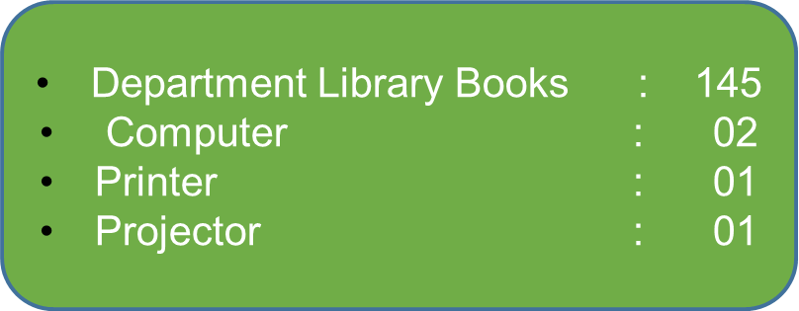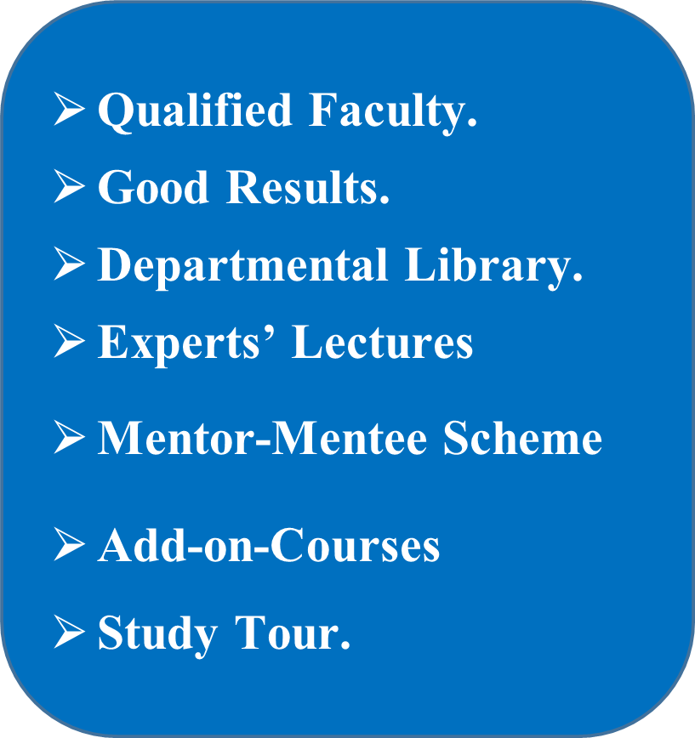

Facilities

**Activities of Department**

1. **Study Tour**
2. **Chhatrpati Shivaji Maharaj Birth Anniversary**
3. **History Knowledge Table**
4. **Writing History of Village**
5. **Student Seminar**
6. **Mentor & Mentee**
7. **Poster Presentation**
8. **Expert Lecture**
9. **Add and Course**
10. **Career Counselling**
11. **Online Quiz**

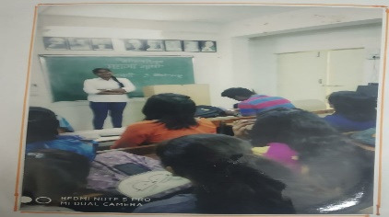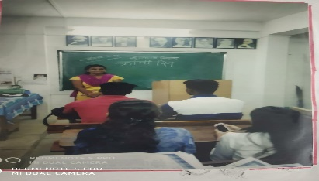**3. Activities:**

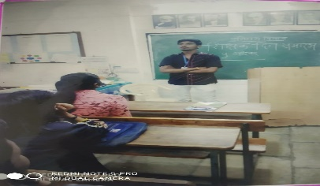

**Swapnali Kamble Dilevering Lecture by**

**Mahatma Gandhi 03/10/2019**

**Ganesh Delivering Lecture by Teachers day 5.9.2019**

Pratiksha Mane Delivering

Lecture by Kranti Din 09/08/2019

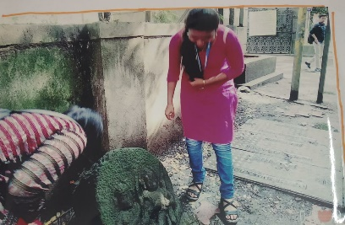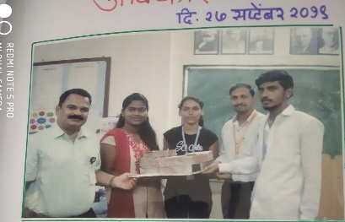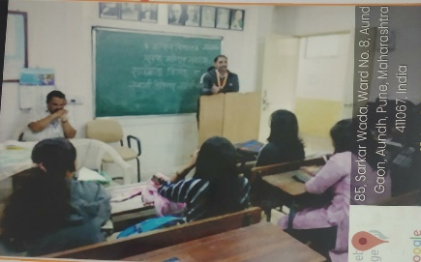

Local Sculpture Study and Cleaning Program

27/09/2019

Prof. Kiran Kumbhar giving guidanceon the occasion of Youth day 13.1.2020

Avishkar Competition Participate Students 27/09/2019

**Staff Research: Dr.Rajendra Raskar**

|  |  |  |  |  |  |  |
| --- | --- | --- | --- | --- | --- | --- |
| **Paper Publication in Journal** | | | | | |  |
| **Title of Paper** | **Name of the Journal** | **Volume** | **Page No** | **Year** | **ISBN/ISSN No.** |
| **Dr.BabasahebAm bedkar’s Thoughts on Annihilation of the Castes in present Context** | Research JourneyInternational EResearch Journal | Special Issue 159 | 14 | Feb. 2019 | ISSN-2348-7143 Impact Factor |
| **The Role of Digital Technologies and virtual new media in the preservation of cultural heritage** | Amierj | Special Issues XVII Vol. VIII | 49 | 23rd Nov. 2019 | ISSN-2278-5655 |
| **Lalalajpatrai’s Contribution in Social Work** | Research JourneyInternational EResearch Journal | Issue-4B Vol-06 | 241 | 31st Dec.201 9 | ISSN-23487143 Impact Factor6.625 |
| **MahrshiVitthalR amjiShindeYanch eSamajikKaryatil Yogdan** | Research JourneyInternational EResearch Journal | Special Issue 22 B | 84 | Jan.2020 | ISSN-23487143 Impact Factor6.625 |

|  |  |  |  |  |  |
| --- | --- | --- | --- | --- | --- |
| **Book Publication Dr. Rajendra Raskar History Dept.** | | | | |  |
| **Sr. No.** | **Book Name** | **Publication** | **Class** | **Year** |
| 1 | Ancient and Medival India | Chetana Publication, Mumbai | 11th | 2006 |
| 2 | Modern India and China | Chetana Publication, Mumbai | 12th | 2007 |
| 3 | Modern India | Aruna Publication, Latur | SYBA | 2016 |
| 4 | Early India:- From Prehistory to The Age of the Mauryas | Success Publications | FYBA  Sem-I | 2019 |
| 5 | Early India:-  Post Mauryan Age to the Rashtrakutas | Success Publications | FYBA  Sem-II | 2019 |
| 6 | Maratha Polity | Success Publications | MA-I  Sem-I | 2019 |
| 7 | Early History of Maharashtra  Satavahana to Rashtrakutas | Success Publications | MA-I  Sem. I | 2019 |
| 8 | Socio-economic History of the Marathas | Success Publications | MA-I  Sem. II | 2019 |
| 9 | Nature of Dalit Movement in Maharashtra | Success Publications | MA-I  Sem. II | 2019 |
| 10 | History of the Marathas(1630-1707) | Success Publications | SYBA  Sem-III | 2020 |
| 11 | Medival India Sultan Period | Success Publications | SYBA  Sem-II | 2020 |
| 12 | Intellectual History of the world(English) | Success Publications | MA-II  Sem-III | 2020 |
| 13 | Intellectual History of the world(Marathi) | Success Publications | MA-II  Sem-III | 2020 |
| 14 | Medieval India(Mughal Period) | Success Publications | SYBA  Sem-II | 2020 |
| 15 | History of the Marathas(Peshave Period) | Success Publications | SYBA  Sem-IV | 2020 |
| 16 | Debates in Indian Historigrophy | Success Publications | MA-II  Sem-IV | 2020 |
| 17 | Indian National Movement(1885-1947)  (G-3) | Success Publications | T.Y.B.A  Sem-v | 2021 |
| 18 | Introduction to Historiography  (S-3) | Success Publications | T.Y.B.A  Sem-v | 2021 |
|  |  |  |  |  |
| 19 | Post- Independence India (1947-1991)  (G-3) | Success Publications | T.Y.B.A  Sem.- VI | 2022 |
| 20 | Applied History  (S-3) | Success Publications | T.Y.B.A  Sem.- VI | 2022 |

Extension Activity

|  |  |  |
| --- | --- | --- |
| **Sr.No.** | **Activity Name** | **Benefishiari** |
| 01 | Poster Presentation | 40 |
| 02 | History Knowledge Table | 202 |
| 03 | Online Quiz | 3523 |
| 04 | Study Tour | 74 |

**Outreach Activity**

|  |  |  |  |  |
| --- | --- | --- | --- | --- |
| **Sr. No.** | **Activity name** | **Date** | **Participant** | **Benefited Students** |
| 1 | Visit to Gurukulam | 02/03/2022 | 10 | 80 |
| 2 | Visit to Gurukulam | 16/10/2019 | 15 | 42 |

1. An outreach program helps to uplift and support those who are deprived of certain services and rights. It involves giving learning, social planning health support and their project for their welfare. Our college is surrounded by various slum area and inhabitants are socially, economically weak. Consequently. The students have less zest for education Department of History under takes teaching to primary students.
2. 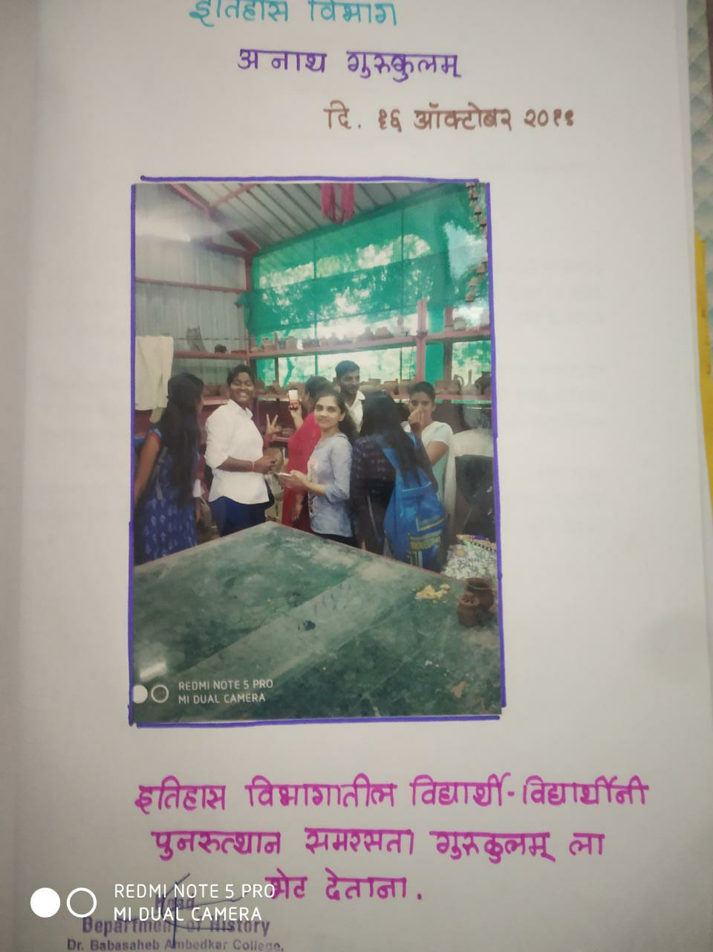The students of department of History of our college shared the History knowledge such as stories of Revolution, Bravery of Chh. Shivaji Maharaj and Freedom fighters.

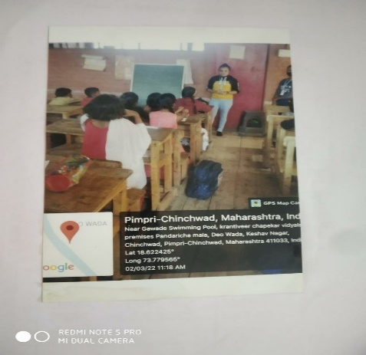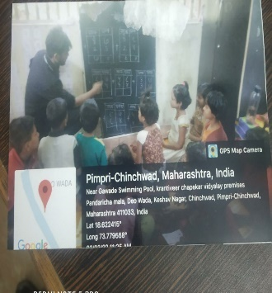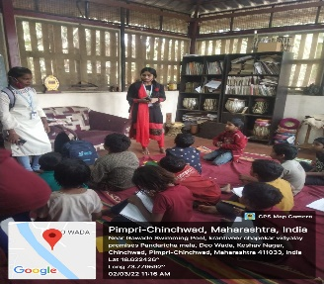

02/03/2022

16/10/2019

02/03/2022

02/03/2022

**SHIVJAYANTI PROGRAM**

2020-2021

2020-2021

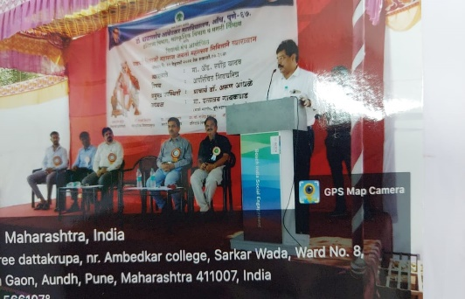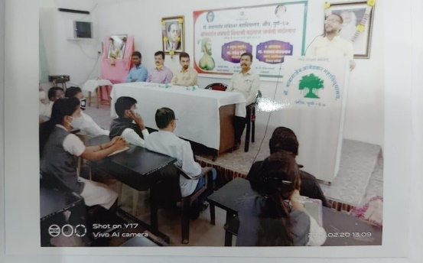

**Prof. Ganesh Shinde 21/02/2021 Adv. Ravidra Yadav 21/02/2022**

**Delivery Lecture of Chhp. Shivaji Maharj Delivery Lecture of Chhp. Shivaji Maharaj**

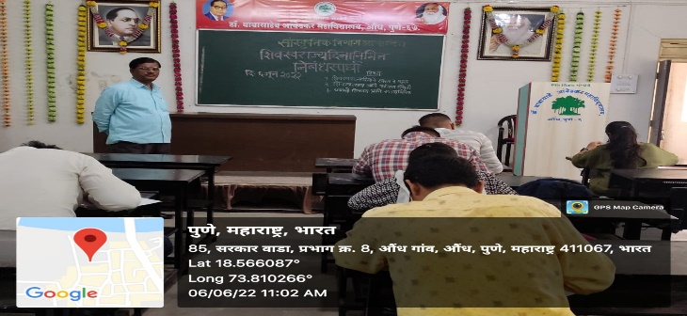**SHIVSWARAJYA DIN**

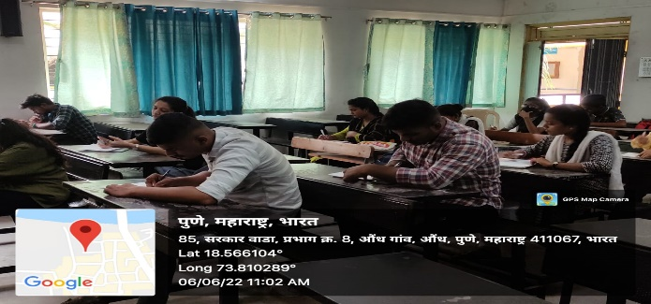

**Essay Competition Occasion of**

**Shivswarajya Din 06/06/2022**

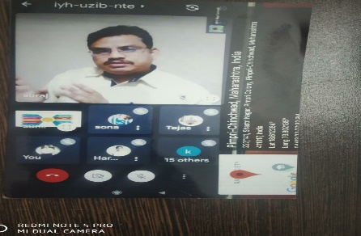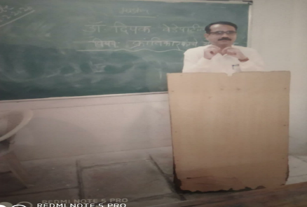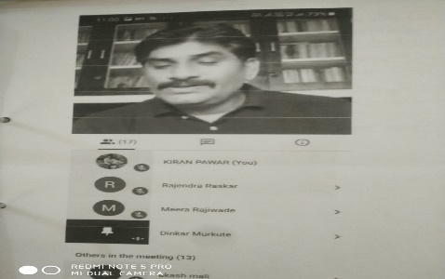

SPECIALECTURE ON ‘ THE CONTRIBUTION OF REVOLUTIONARY’ Dr. Dipak Vedepatil 22.02.2020

Dr. Suraj Sonwane Delivering a lecture on Spicer University Competitive Exam Preparation 04/03/2021

Prof.Dr. Dinkar Murkute giving an Online Lecture on the Contribution of Kranti Din

09/08/2020

**FUTURE PLAN**

* **To organize national and International level Seminar**
* **To organize study tours to historical places in all over India**
* **We will start P.G. Course**
* **Planning to open a Historical Museum**